**CUSTOMER SIDE**

**User_ sequence: Login**

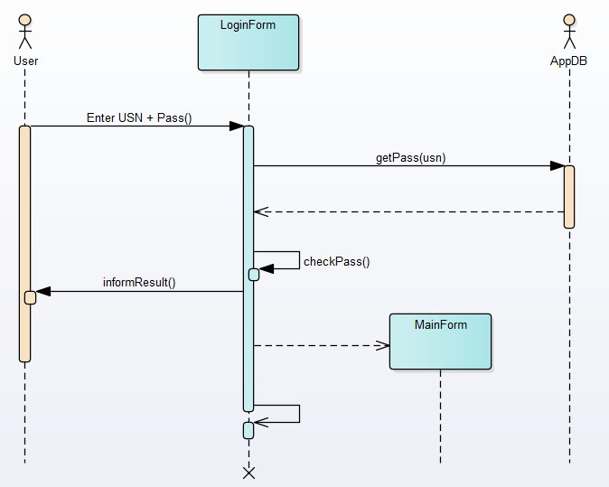

**User_sequence: Sign up**

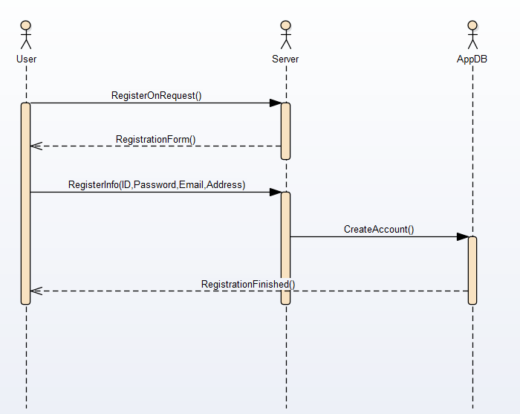

**User_ sequence: App interface**

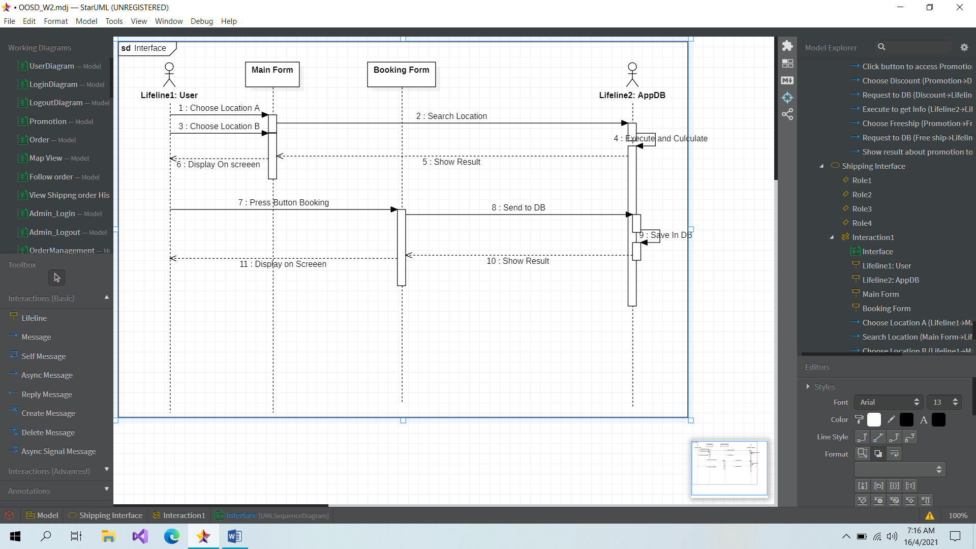

**User_usecase: Map view**

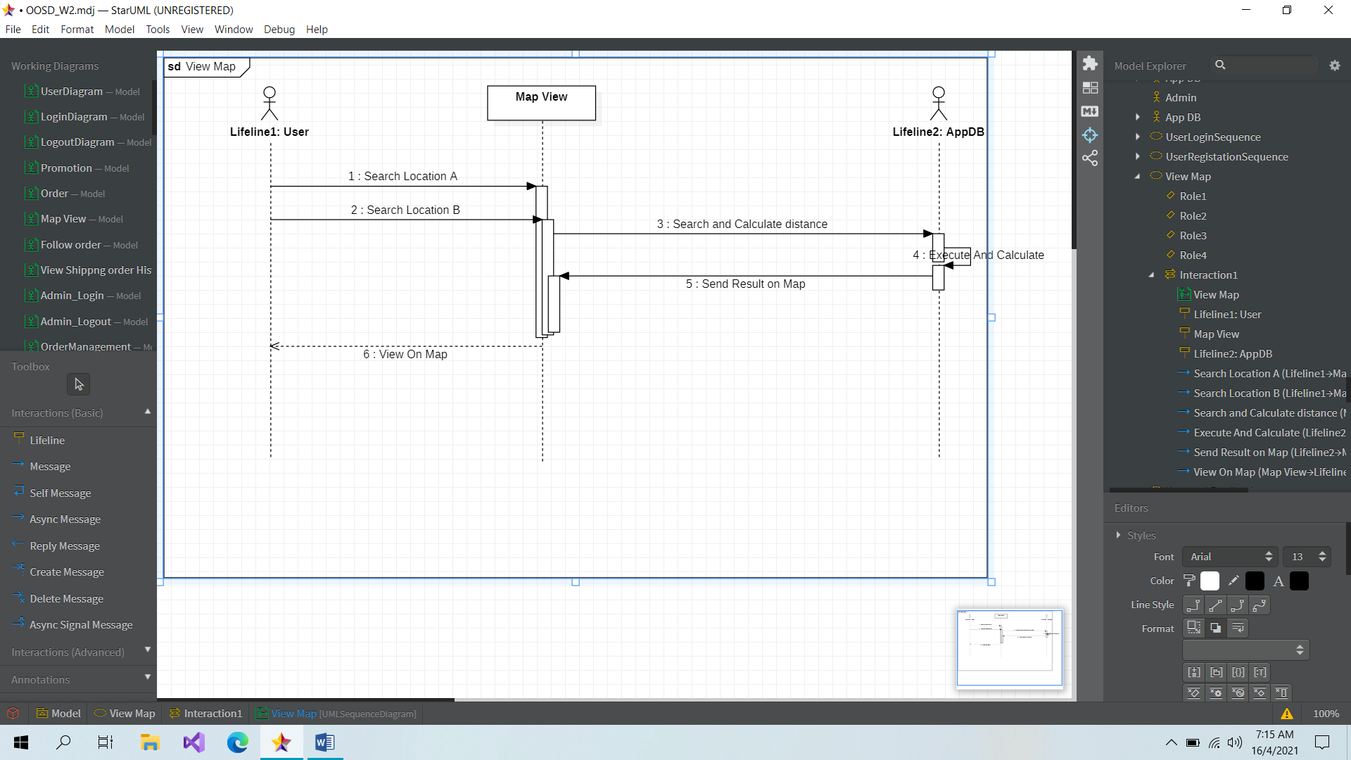

**User_sequence: Vote & Feedback**

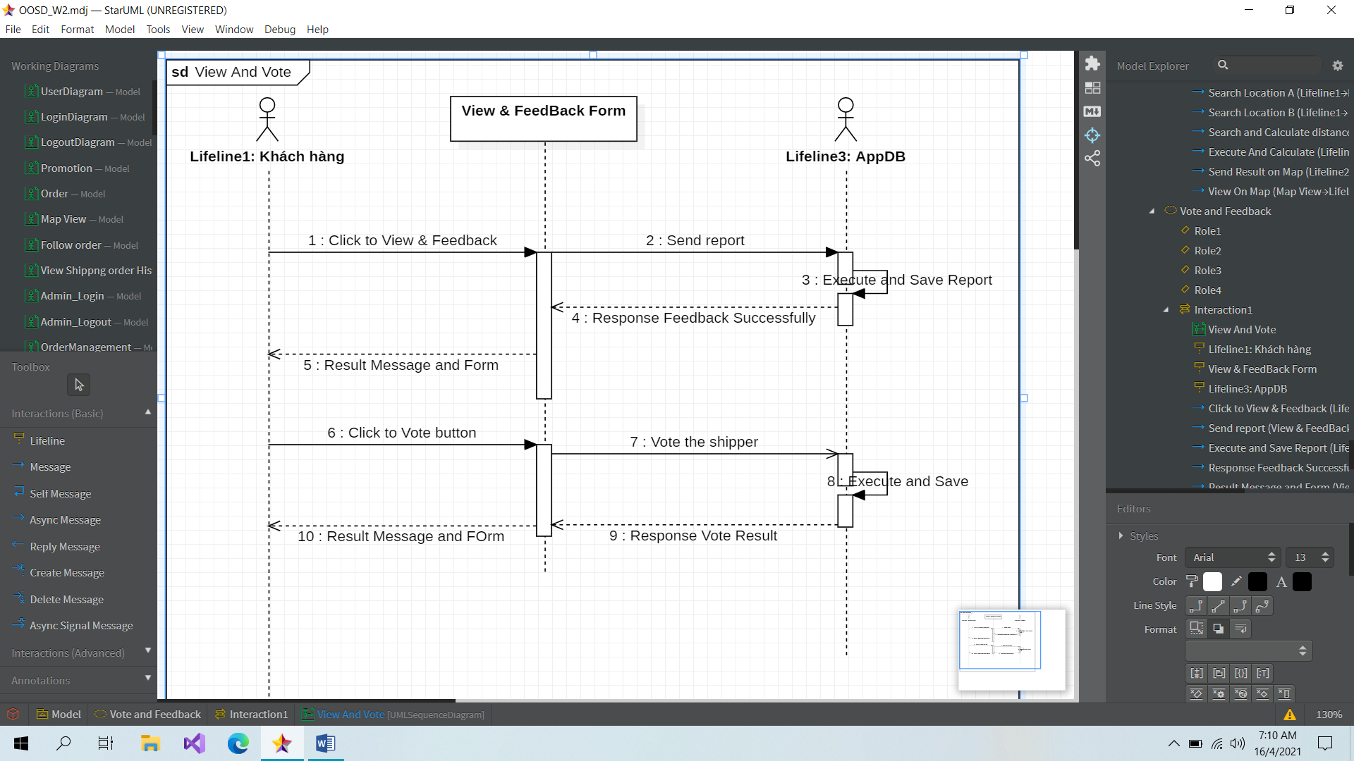

**User_sequence: Promotion**

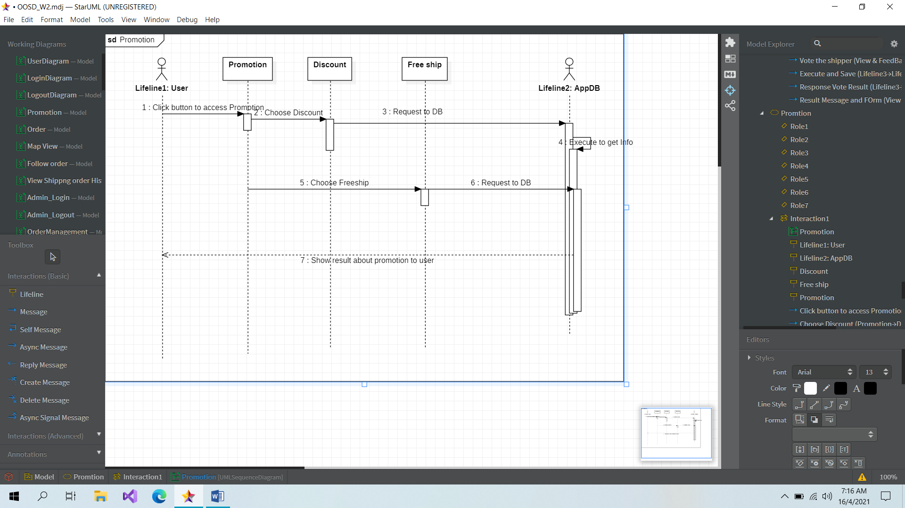

**User_sequence: Search Shipping Unit**

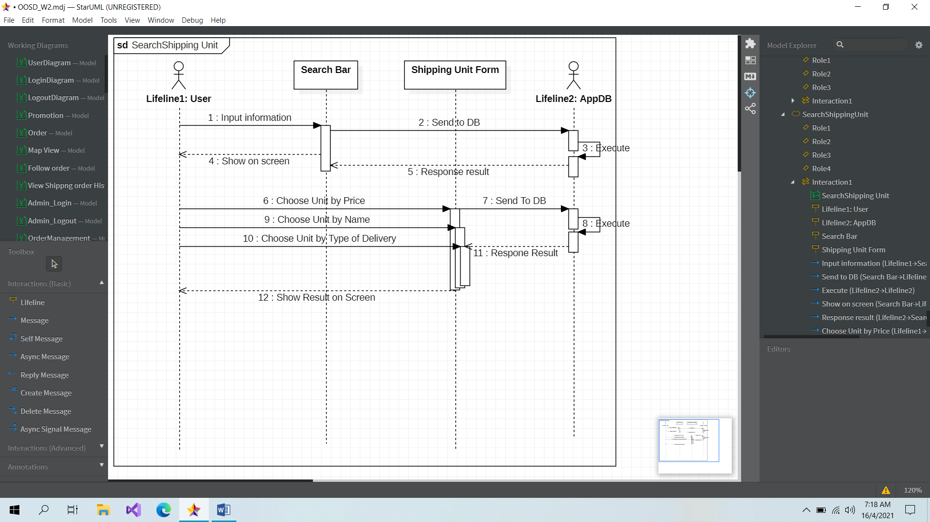

**User_sequence: Order**

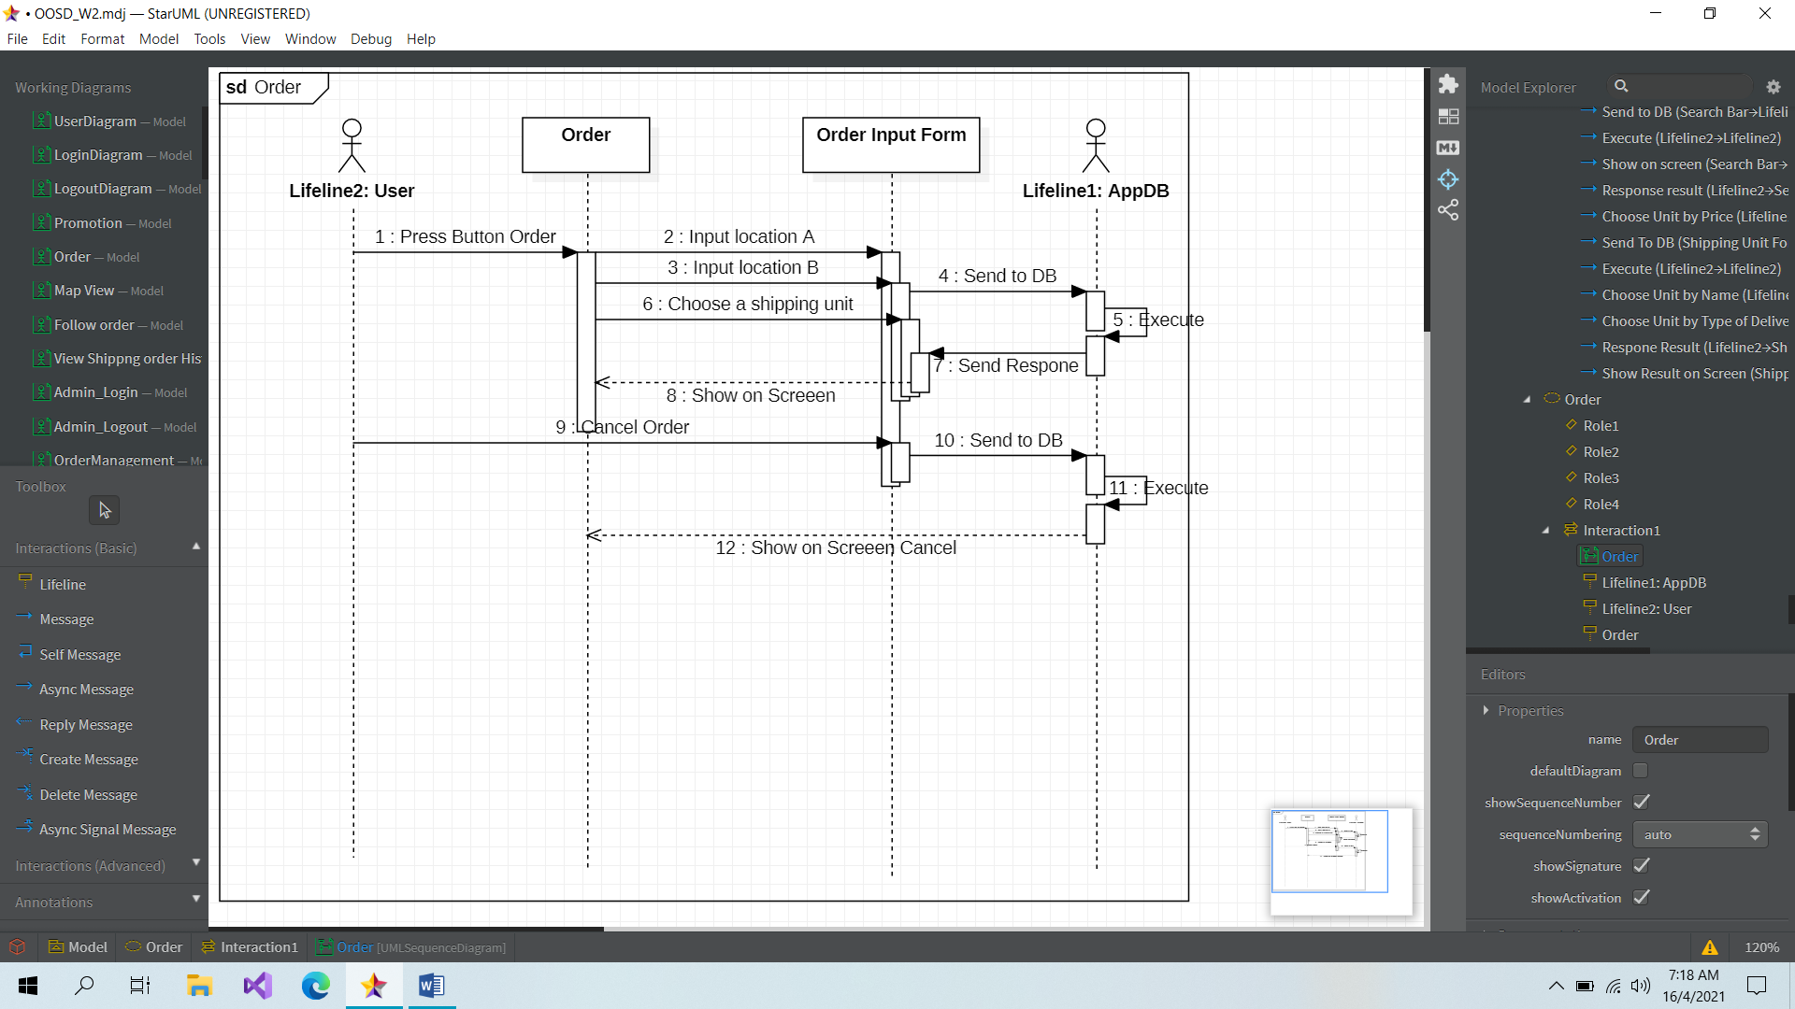

**User_sequence: Order’s history**

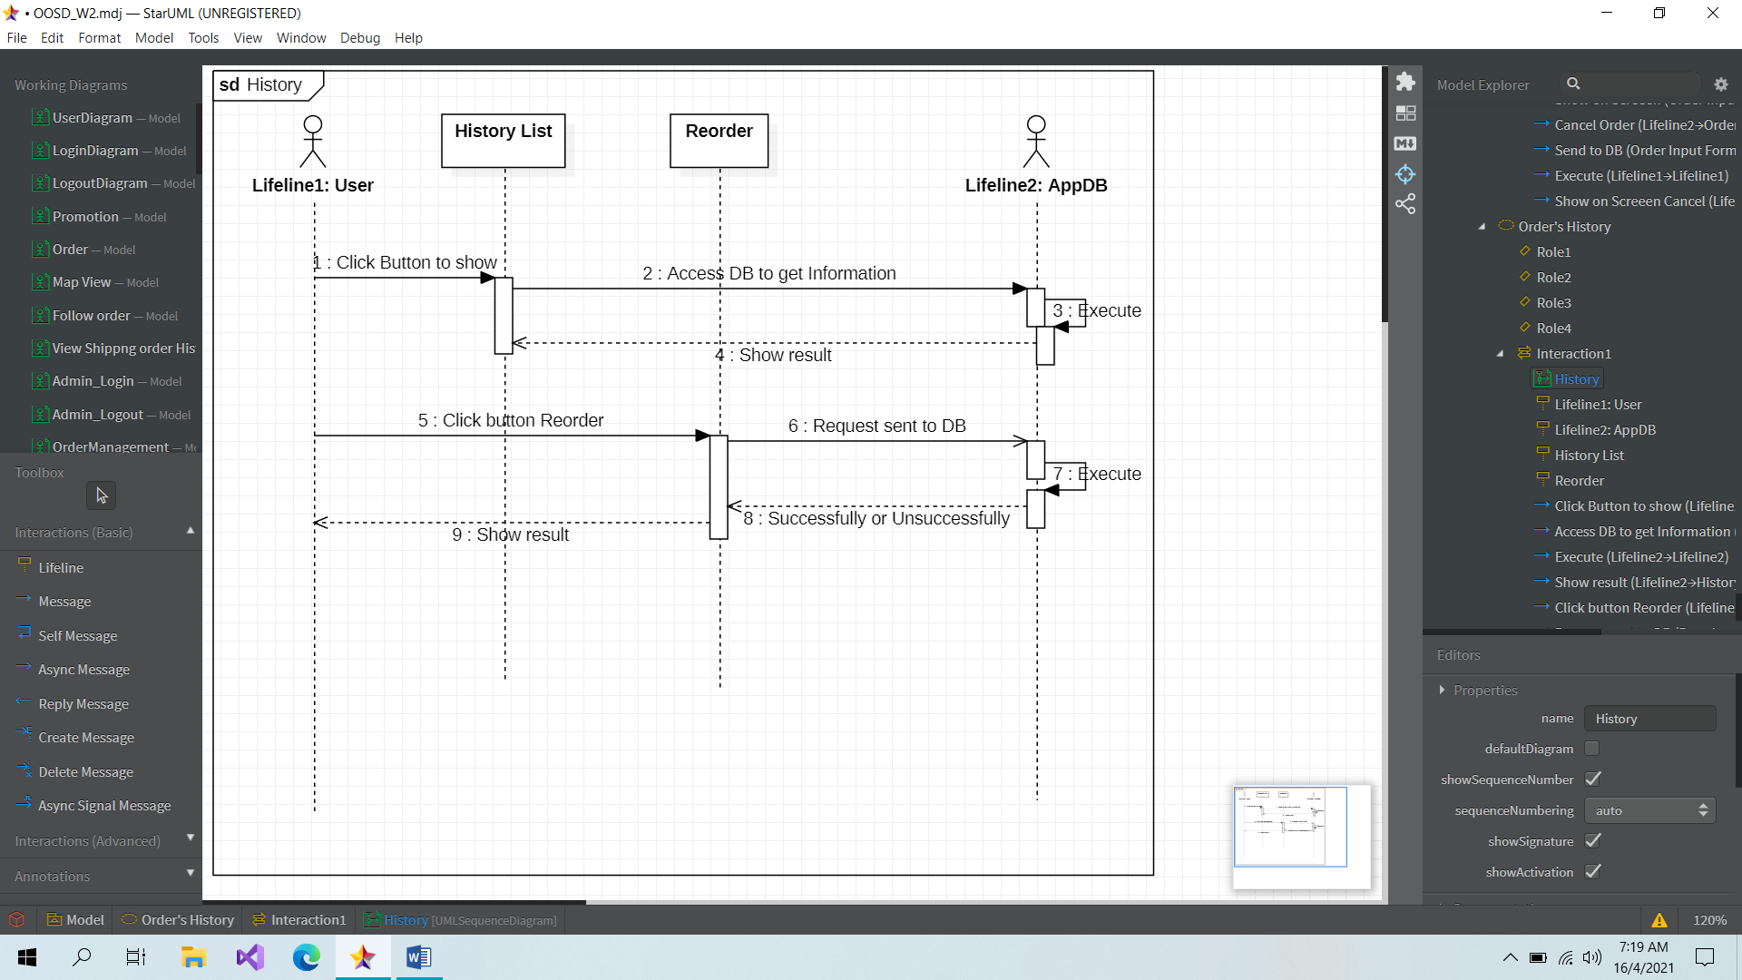

**SHIPPER SIDE**

**Shipper_sequence: Login**



Shipper

**Shipper_sequence: Sign up**



Shipper

**Shipper_sequence: Add a new location**

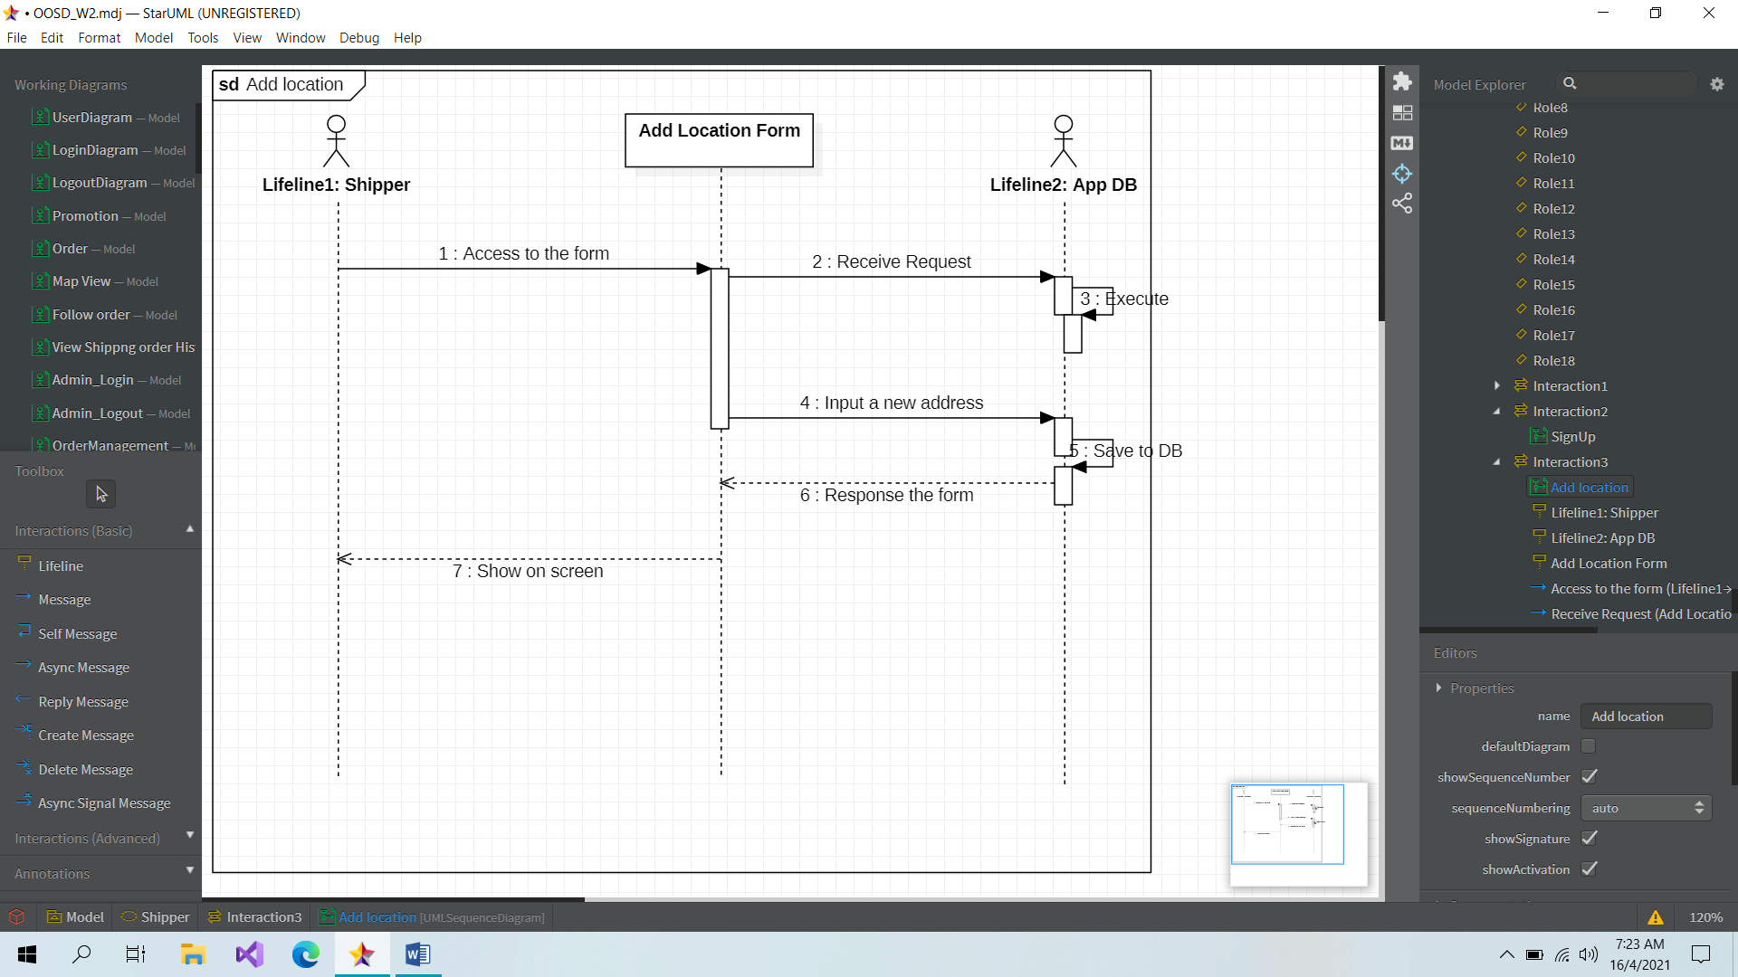

**Shipper_sequence: Deliver many order**

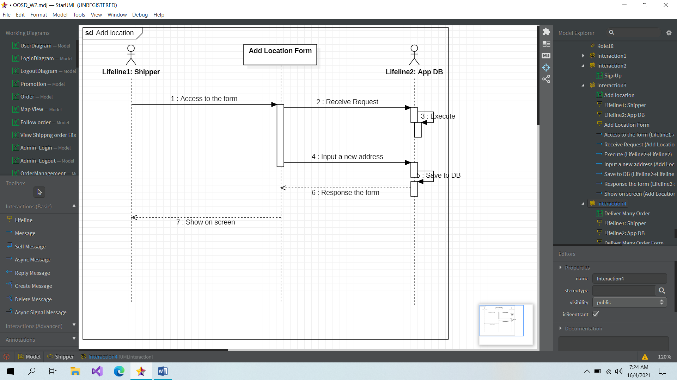

**Shipper_sequence: Find the shortest way**

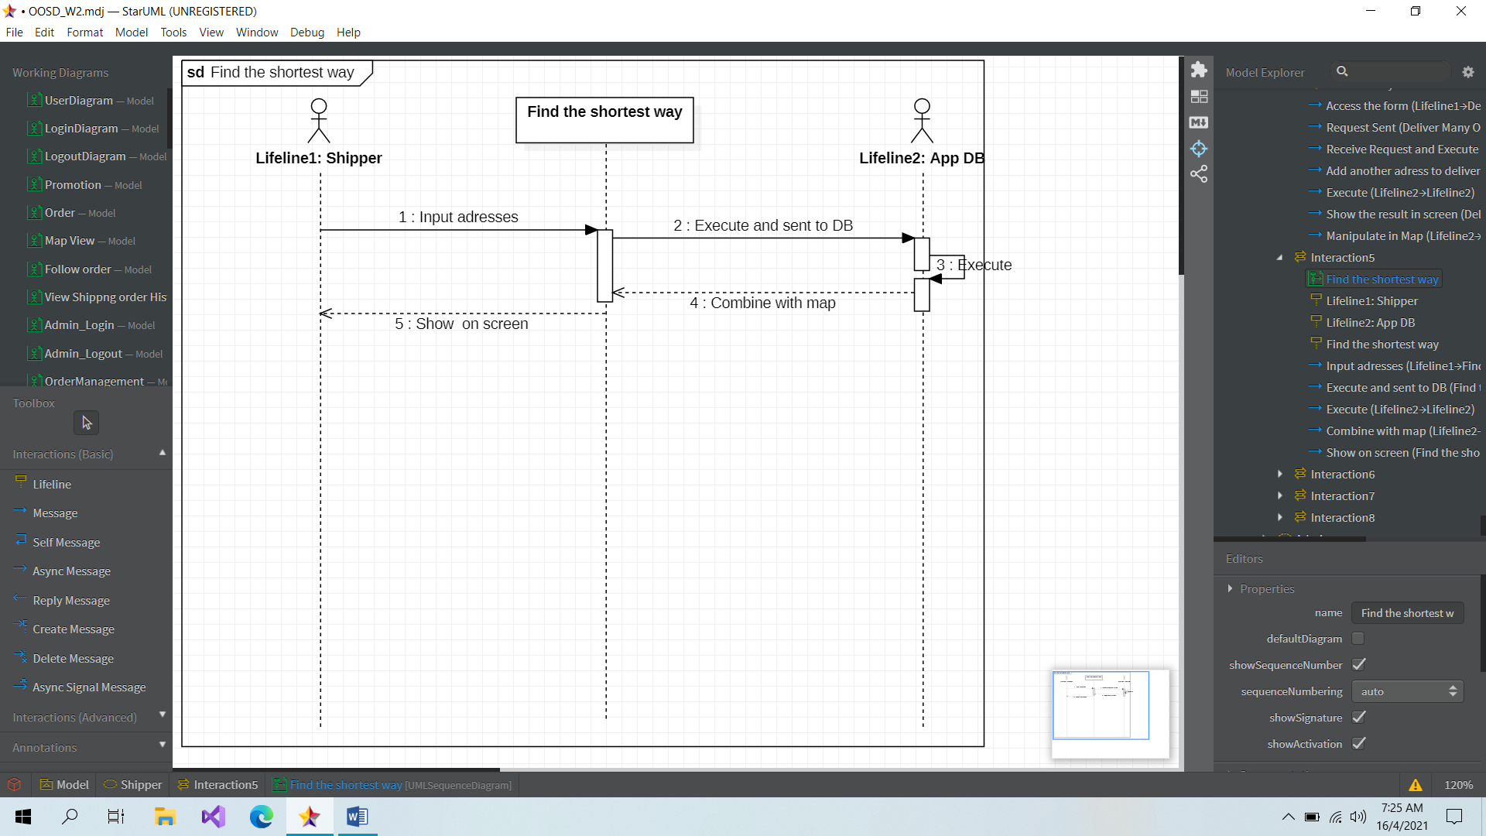

**Shipper_sequence: Recalculate way to avoid traffic jam**

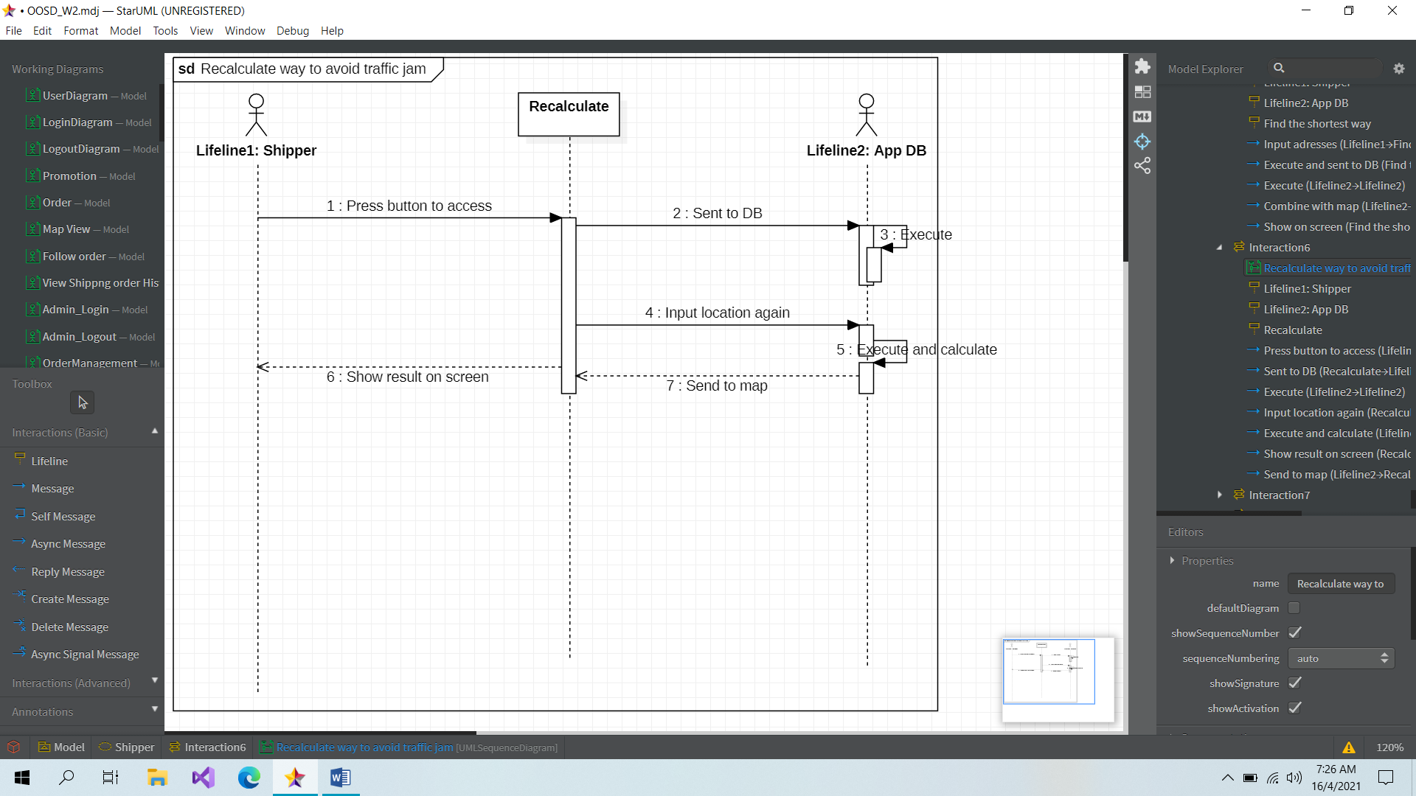

**Shipper_sequence: Change shipper**

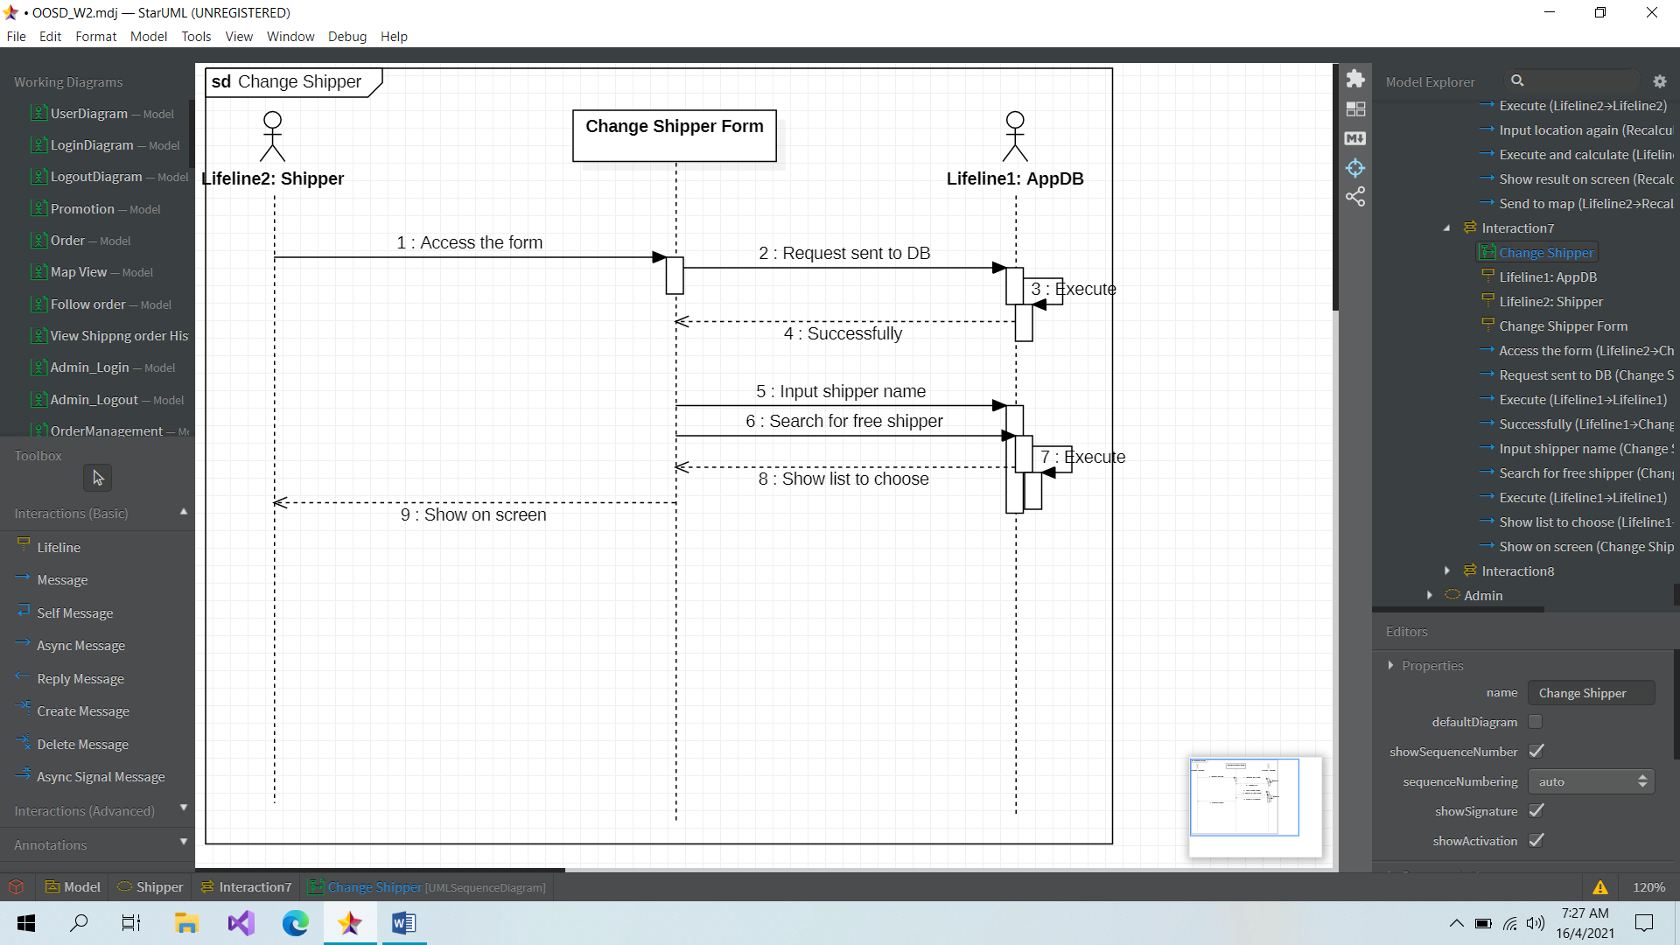

**Shipper_sequence: Cancel order**

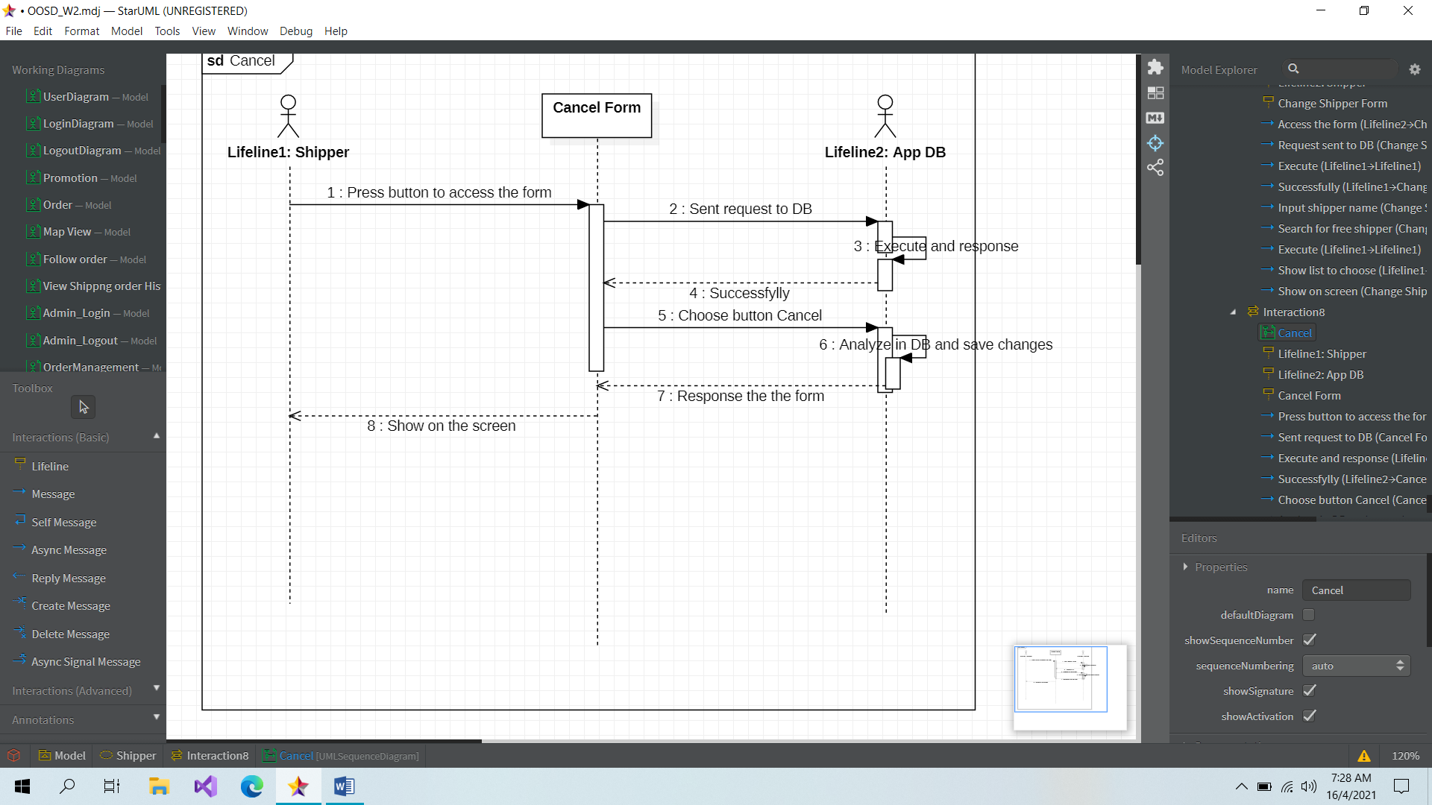

**ADMINISTRATOR SIDE**

**Admin_sequence: Login**



Admin

**Admin_sequence: Sign Up**



Admin

**Admin_sequence: Manage Shipper**

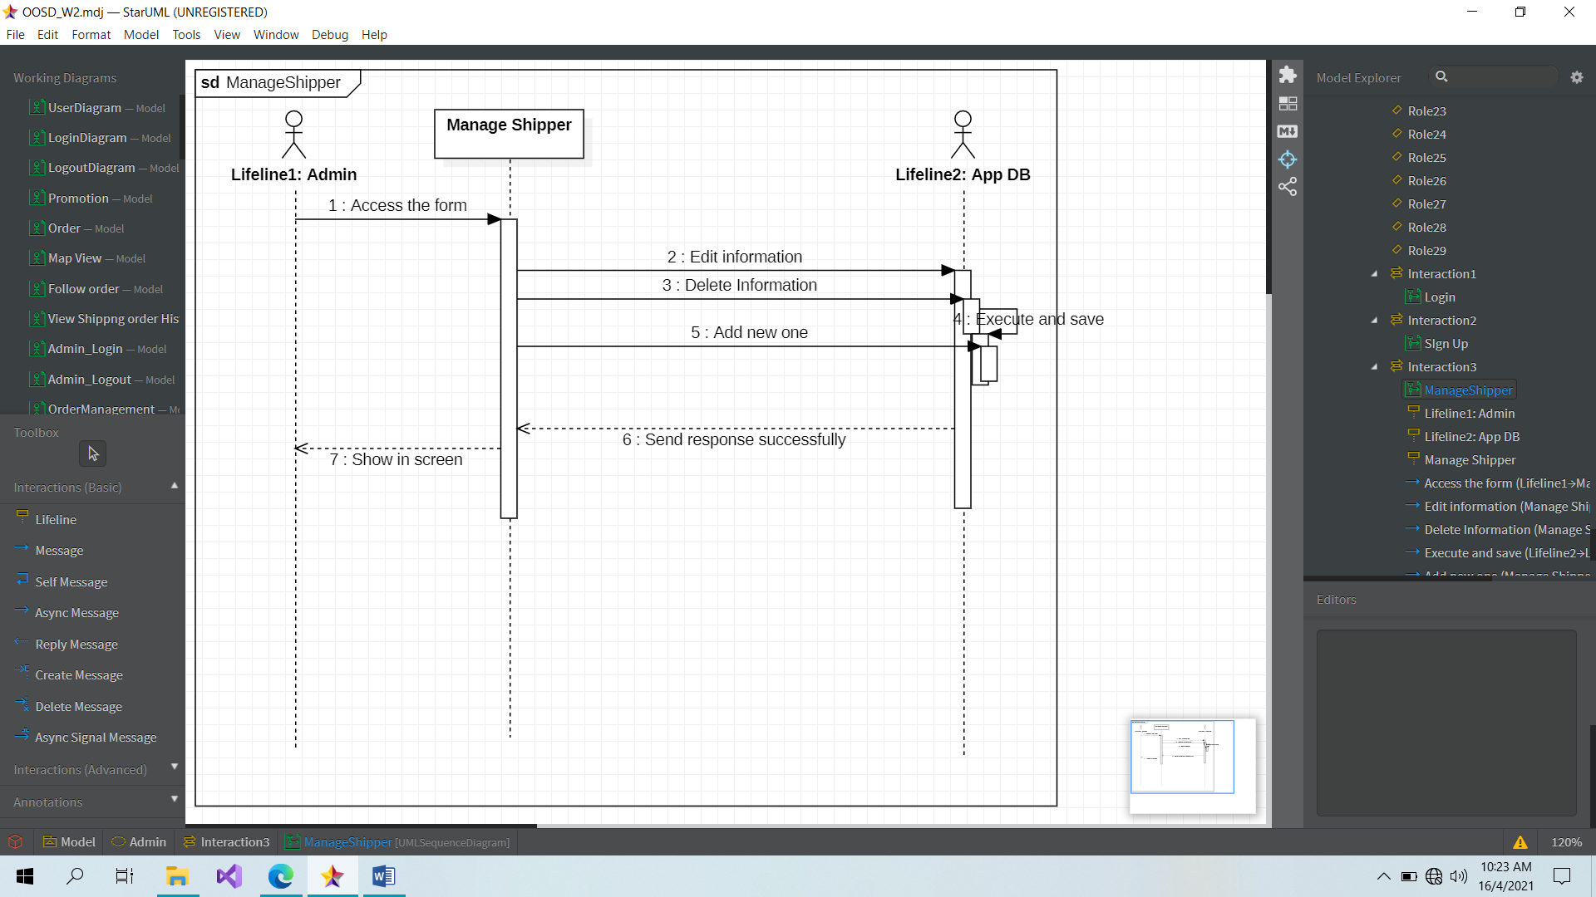

**Admin_sequence: Manage Customer**

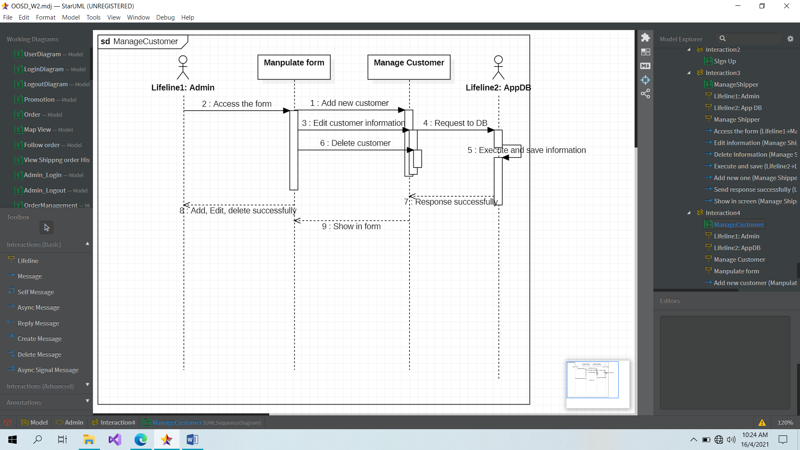

**Admin_sequence: Modify Price**

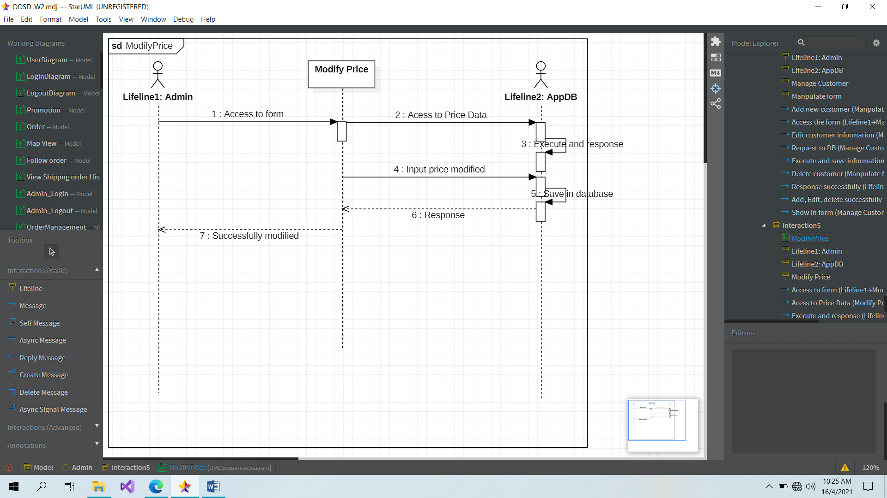

**Admin_sequence: Add a new shipper or a new customer into system**

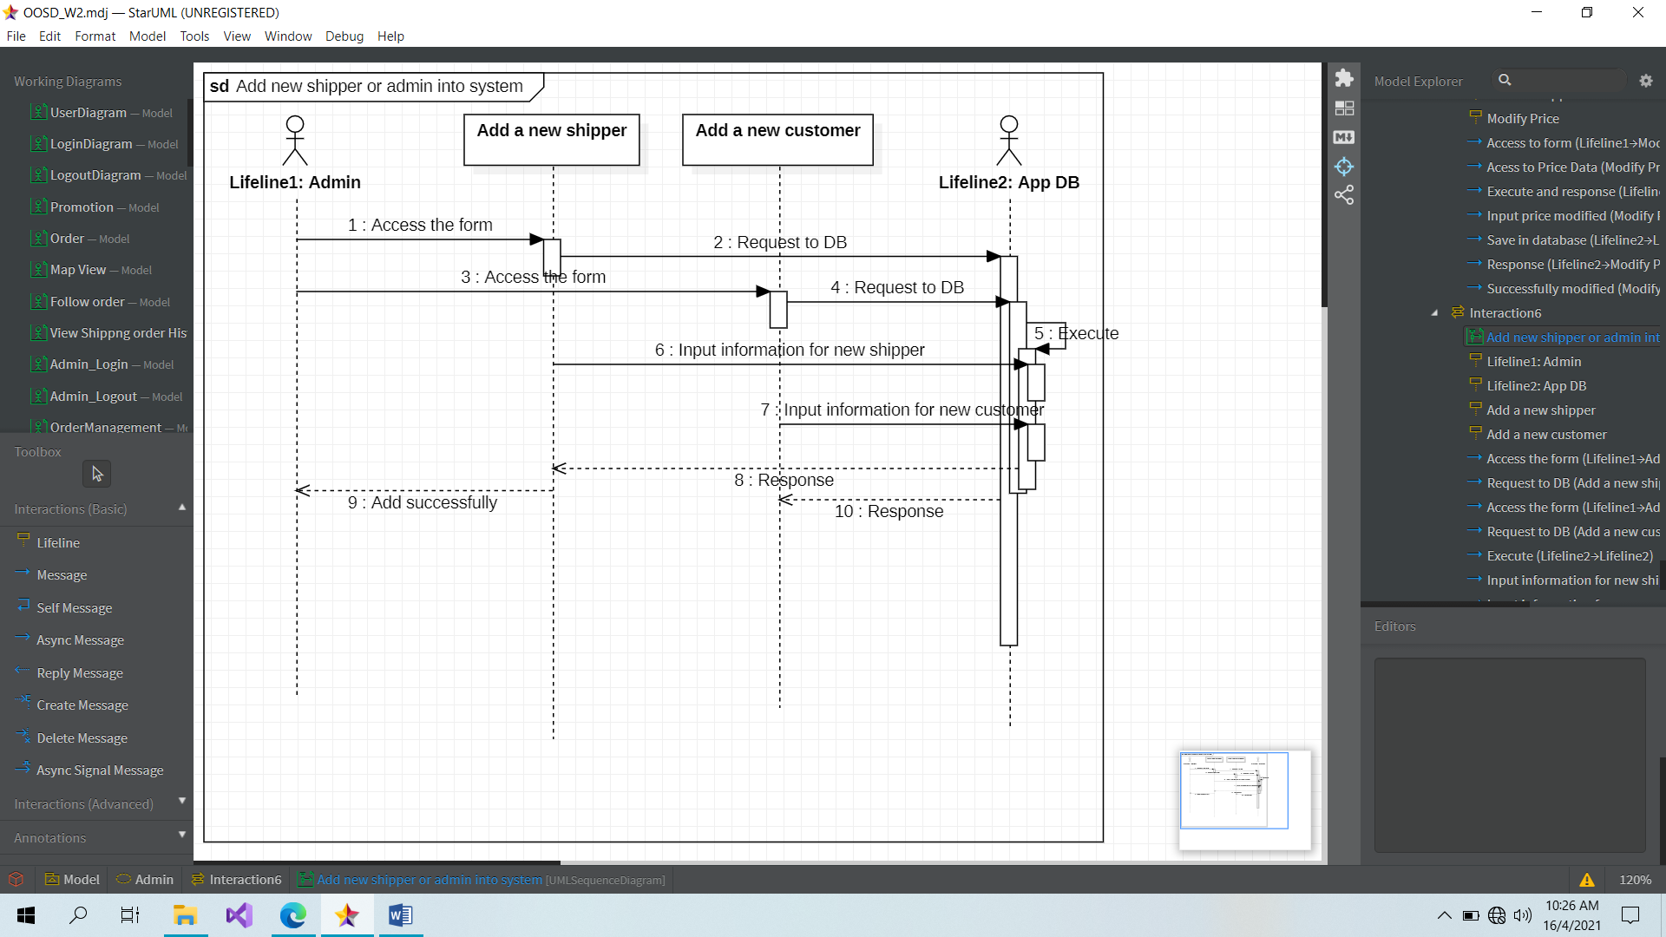

**Admin_sequence: Send invoice via customer email**

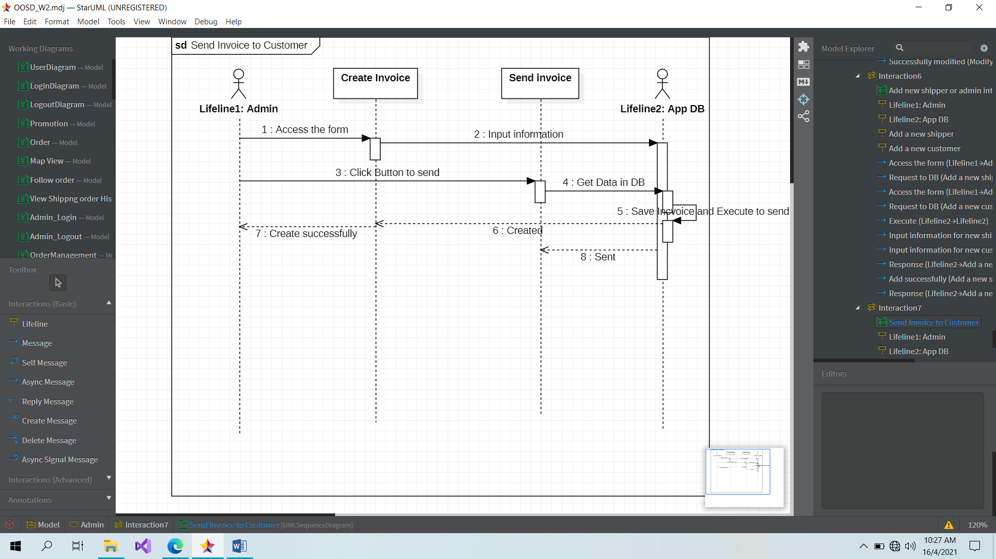

**Admin_sequence: Block shipper**

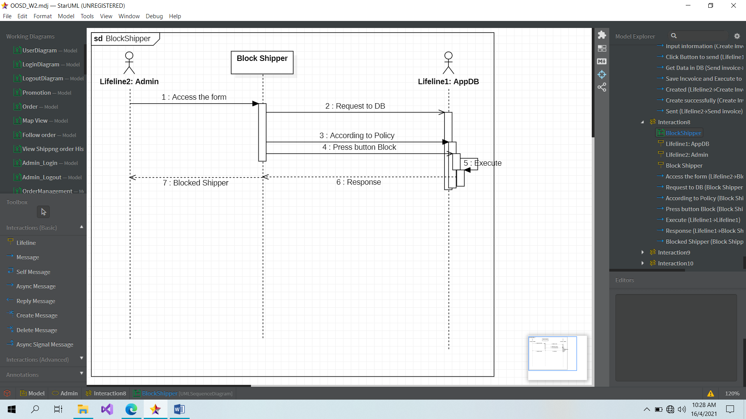

**Admin_sequence: Block customer**

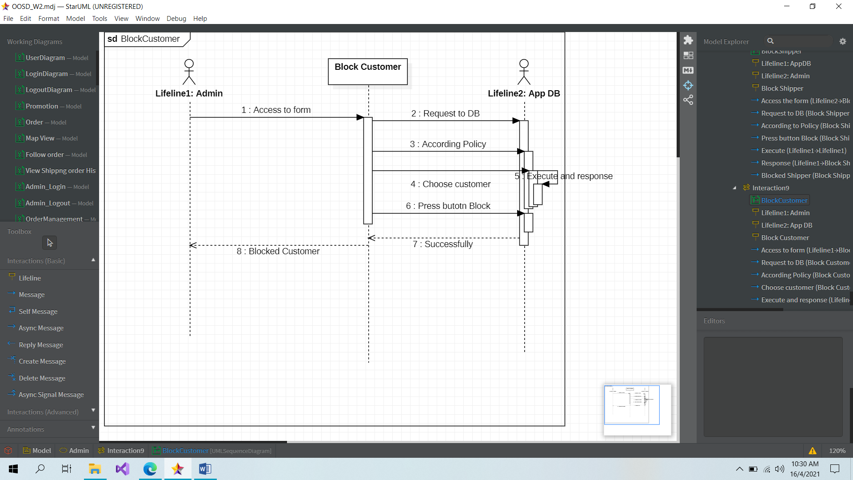

**Admin_sequence: Send promotion**

